UBND THÀNH PHỐ HỒ CHÍ MINH CỘNG HÒA XÃ HỘI CHỦ NGHĨA VIỆT NAM
TRƯỜNG CAO ĐẲNG KỸ THUẬT Độc lập - Tự do - Hạnh phúc
LÝ TỰ TRỌNG TP. HỒ CHÍ MINH

LESSON PLAN

Teacher: Trần Thanh Trúc
Subject: English 2
Date: 28/3/2017
Time allocated: 45’

UNIT 5: How was your vacation?
Reading: You call this a vacation?!

I. OBJECTIVES
By the end of the lesson, the students will be able to:
- Learn some new words about the topic “Vacation”
- Practice guessing the main idea of the reading passage from the title and the illustrations.
- Practise scanning the reading text for specific information.

II. METHOD
- Integrated, communicative oriented teaching approach.

III. TECHNIQUES
- Individual work
- Pair work.
- Group work

IV. TEACHING AIDS
- Textbook.
- Black board, chalk.
- Handouts
- Ppt file and overhead projector
- CD and cassette

V. PROCEDURE
- Greetings.
- New lesson.

 | Teacher (T) | Students (Ss)
5’ | - Activity 1: Warm up and lead in  - Asks Ss the question:  “What do you usually do on your vacation?” | - Answer the T’s question.
10’ | - Activity 2: Pre-reading  - Introduces the topic of the reading text.  - Teaches some new words (asks concept - checking questions when necessary)  peak (n) – using picture and synonym.  challenge (n) – using translation.  exhausted (adj) – using picture and synonym.  raise money for charity – using picture and example.  drive – drove from … to … (v) – using example  do – did (v)  make – made (v) | - Listen to the T.  - Listen and respond to the T.  - Take note new words.
20’ | - Activity 3: Reading comprehension  - Task 1: Guess the main idea  - Focuses Ss’ attention on the map and the picture.  - Asks Ss to guess the main idea of the reading passage based on the map and the title.  - Shows Ss how to pronounce the names of the mountains and cities.  - Task 2: Read and answer the questions  - Plays the cassette and lets Ss listen to the recording of the reading passage.  - Gives instructions and helps Ss identify the key words in the questions.  - Has Ss do the activity in pairs.  - Checks answers: has Ss locate information and explain their answers | - Look at the picture and the map.  - Answer the T’s questions and guess the main idea of the reading passage.  - Listen to the T and repeat.  - Listen to the recording.  - Listen to the T and respond.  - Do the activity.  - Check answer.  Expected answer:  - Her friend Andy  - She thought that’s crazy.  - She felt exhausted  - She felt happy  - $1000
10’ | - Activity 4: Post- reading  - Asks Ss to summarize the journey of the Three Peaks Challenge by filling in the blanks (Appendix)  - Asks Ss if they want to do the Three Peaks Challenge. | - Do the task.  Expected answer:  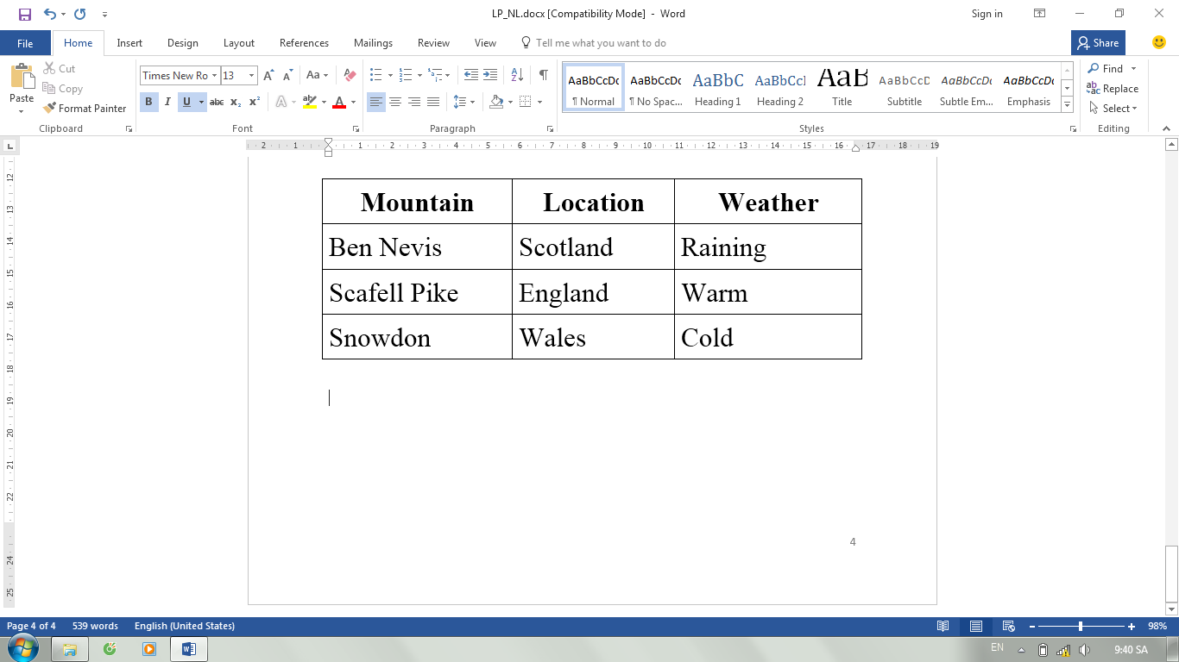  - Answer the T’s question..
 | - Back-up activity  - Consolidates the vocabulary | - Participate the activity

VI. SELF-ASSESSMENT:
- The teaching methods are good because:
+ There are facilities and materials for students to study better.
+ The teacher’s preparation is careful.

VII. APPENDIX
Use the following words to fill in the table:
Warm England Wales raining Scotland cold
Mountain | Location | Weather
Ben Nevis
Scafell Pike
Snowdon

THÔNG QUA TỔ BỘ MÔN Chữ ký giáo viên

NGUYỄN THỊ MINH QUÝ Trần Thanh Trúc

